Cornerstone Christian School
Middle School & High School
Physical Education Uniform Order Form

Please complete one form for each student.

Student Name Grade

Qty | Item |  | Size (Please circle your choice) |  | Unit Price | Line Total
 | Blue Shorts |  | Adult sizes  Youth L S M L XL |  | $11.00 | $
 | Grey T-shirt |  | Adult sizes  Youth L S M L XL |  | $6.00 | $
 |  |  |  |  | GRAND Total $
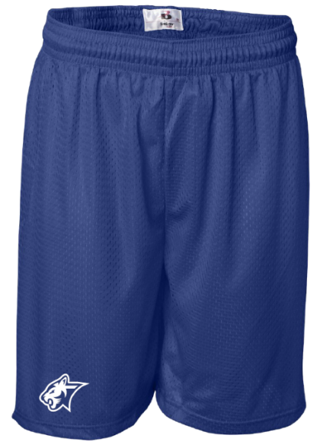 |  |  |  | 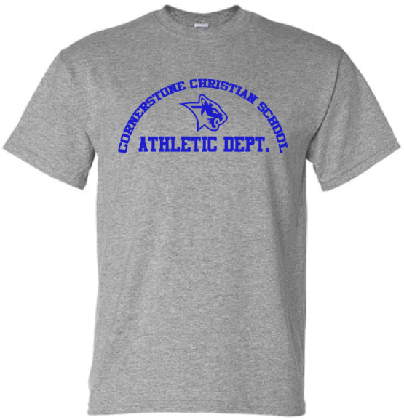
-----------------------------------------------
Please return this uniform order form and payment to the front office.
Orders needed for the beginning of the school year,
must be submitted no later than July 27th
to ensure they’ll be available for the first week of school.
- Please check here if you plan to pay your bill online via Family Portal.
For Office  Use Only | Amount:  ¨ Entered in FACTS | ¨ Check #  ¨ Cash ¨ Family Portal | Date:  Initials: | Filled Date:  Filled By:

