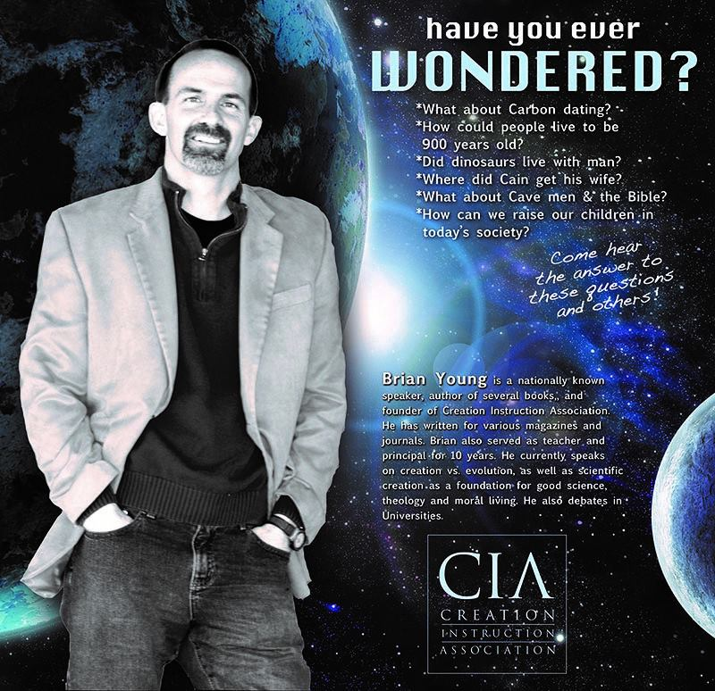

**Important Dates:**

* **Reading Logs are due Monday! 😊**
* Brian Young Presentation Sat., April 13th (Information below)
* International Day Mon., April 15th
* Middle School Shadow Day Tues., April 16th (All morning)
* No School Easter Break, April 18th-22nd

Fifth Grade Times

**Design a Board Game Project**

**Book Approved by:** Wed., April 24th

**Book Finished by:** Wed., May 1st

**Project Finished by:** Wed.,May 15th

Contact Info:

**Mrs. Bookless**

sarabookless@ccsnebraska.org

**Mrs. Smith**

asmith@ccsnebraska.org

**Mrs. Anderson**

manderson@ccsnebraska.org

**Have You Ever Wonderered?**

**What:** Brian Young from Creation Instruction Association. You don’t want to miss his presentation, teaching a biblical worldview of “Dinosaurs, Ice-Age and the Preflood World”!

**When:** Saturday April 13th at 3:00pm and 6:30pm

**Where:** At the Elementary/Middle School campus. Bring your friends, neighbors and relatives! No RSVP necessary.

*Brian Young is pictured above

**Band Announcement**

**Monday-** Trumpet and Baritone Sectionals

**Wednesday-** Flutes and Clarinet Sectionals



**Middle School Shadow Day**

**Time:** 8:20am Our day will start with Middle School chapel-We will let 5th graders come into our classes at **8:05am** this morning so they are prepared for the morning with the middle schoolers.

**Date:** April 16th, 2019

**Where:** Middle School Classes

**What:** The 5th graders will be seperated into four groups and they will attend four classes in the morning with the middle school students. They will attend recess with the middle schools students and afterwards have a question and answer time with two of our lovely middle school teachers. This will give our 5th graders a small taste of how middle school will run next year. It should be a learning experience and we hope they get a few questions answered about how next year will look at Cornerstone Christian Middle School. 😊

**Field Trips**

**Lauritzen Garden-** Fri., April 26th

**Storm Chasers-** Mon., May 6th

**Thrasher Family Cabin-** Mon., May 13th (Hopefully)

*More Details to Come!*

**Memory Work**

**due Thursday, May 2nd**

1 Timothy 4:12-13 English Standard Version (ESV)

**12**Let no one despise you for your youth, but set the believers an example in speech, in conduct, in love, in faith, in purity. **13**Until I come, devote yourself to the public reading of Scripture, to exhortation, to teaching.



