5th Grade Times

**Mrs. Goodsell:**

cgoodsell@ccsnebraska.org

**Mrs. Bookless**

sarabookless@ccsnebraska.org

Contact Info:

**Important Dates:**

* **Math Test** Wednesday 1/6
* **Spelling Test** Friday 1/8

**Spelling Words**

**List 17**

1. social
2. partial
3. decision
4. delicious
5. politician
6. precious
7. physician
8. substantial
9. description
10. compassion
11. commercial
12. conversation
13. Pacific
14. Mariana
15. undersea
16. subduction
17. lithosphere
18. depressions
19. topographic
20. aquamarine
21. submarine
22. circumscribe
23. describe

**Challenge**

1. allegiance
2. medication
3. melodic

**Nation Notebook**

Students will be choosing a country for their Nation Notebook project over Christmas break. More details will be sent home when students return.

**Biography Presentations**

The fifth grade students did an excellent job on their biography report presentations!

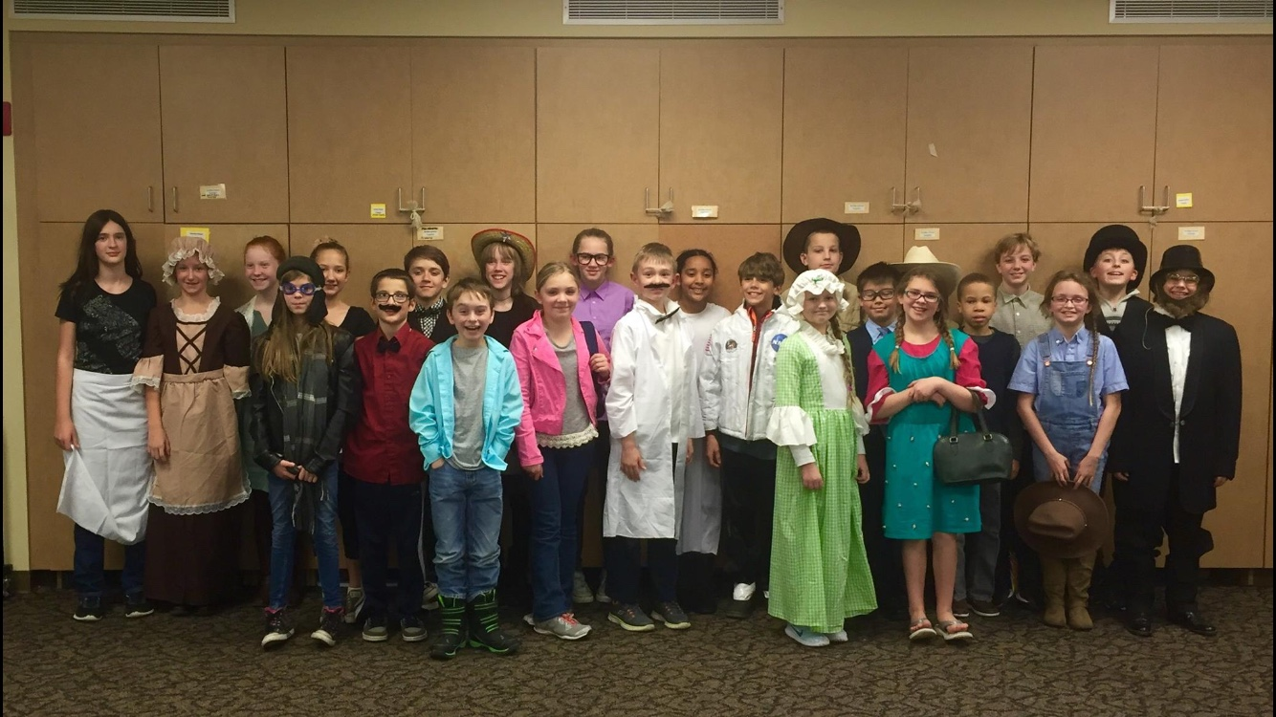

We are so thankful for all of our fifth grade families. We hope you enjoy this season of celebrating our Savior’s birth and spending time with your students. Have a Merry Christmas!

Mrs. Goodsell & Mrs. Bookless