**Important Dates:**

* Last Library Mon., May 20th (Bring back ALL books)
* Math Test Mon., May 20th
* Awards Night Grades 1-5 Tues., May 21st at 7pm at Beautiful Savior Church
* Last Day of School Wed., May 22nd (Noon Dismissal)

Fifth Grade Times

Contact Info:

**Mrs. Bookless**

sarabookless@ccsnebraska.org

**Mrs. Smith**

asmith@ccsnebraska.org

**Mrs. Anderson**

manderson@ccsnebraska.org

**Field Trip Drivers**

Families, thank you for your willingness and support in our field trips and being drivers for our teams! You have all been a dear blessing to us! We couldn’t have done all of the wonderful outings without each and everyone of you! 😊

**Band Announcement**

**Monday-** 😊Turn in rental instruments and pass in music. No playing! Band party! Bring a snack if you want.

**Wednesday-** No band

**Thank you!**

Dear 5th Grade Families,

Thank you for walking with us on our journey throughout this 5th grade year. It has been a joy watching each of these wonderful students grow. Your love and support has been greatly appreciated. Thank you for coming along side us in the long hours of checking math, doing reading projects, Nation Notebook work, and all of the other things you have done to support our Team. WE love you!

Love, 5th Grade Teachers

**LAST Field Trip Fun Pictures**

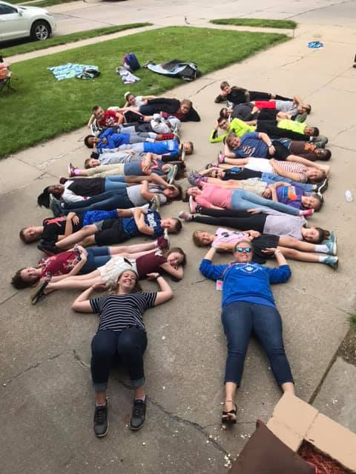

**Finish the year strong 5th Grade! 😊**

**Mountain Mindset!**

We are in the last days of 5th grade.

We have almost finished our climb but we have to finish strong!

1. The climb hasn’t been easy but we have had hope in the climb.
2. Our friends who have helped us along this year have built us up.
3. Don’t forget we committed to this climb and we have to finish strong!

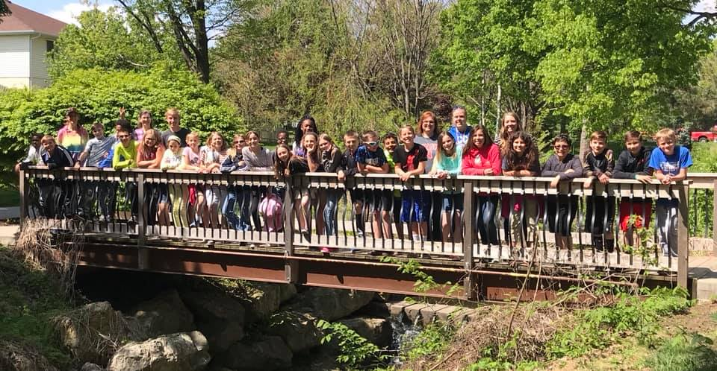

Dark Gray Straight thick arrow You will be missed!