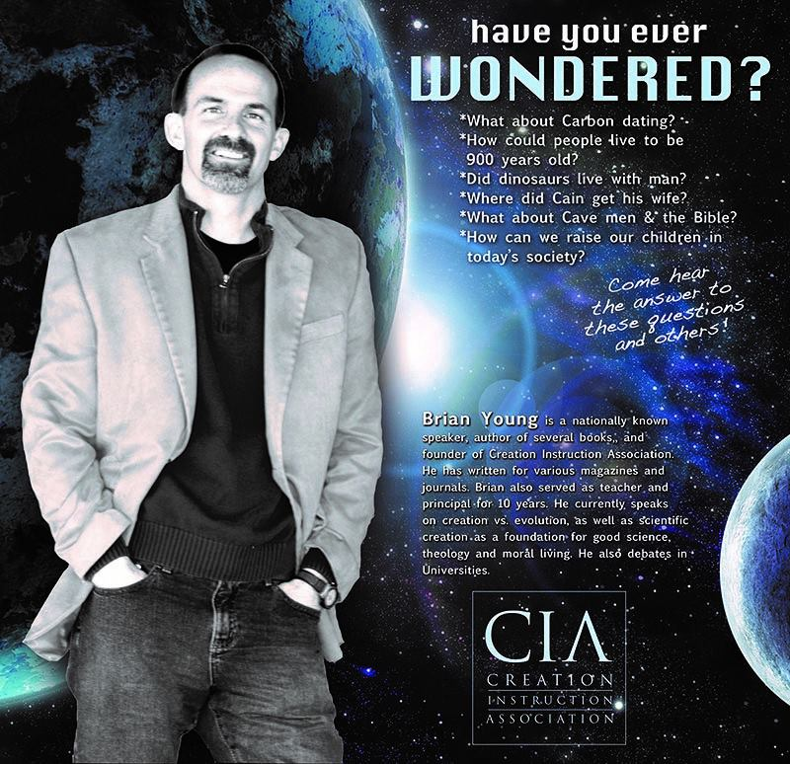

**Important Dates:**

* **Reading Logs are due Monday! 😊**
* Memory Work Thurs., April 11th
* **Speech and Math Meet Fri., April 12th (Information below for each!)**

Fifth Grade Times

**Memory Work**

**due Thursday, April 11th**

**Hebrews 13:5-6 (ESV)**

**5**Keep your life free from love of money, and be content with what you have, for he has said, “I will never leave you nor forsake you.” **6**So we can confidently say,“The Lord is my helper;  
    I will not fear;  
what can man do to me?”

**CCS Math Meet**

**Time**: 10:00am

**DATE:** Friday, April 12th, 2019

**Where:** Lincoln Christian School

**Address**:

5801 S 84th St, Lincoln, NE 68516

Please be praying for our competors!

**Reasoning:** Gia, Evan, and Ella C.

**Computation:** Josh M., Sarah, and Christian

Contact Info:

**Mrs. Bookless**

sarabookless@ccsnebraska.org

**Mrs. Smith**

asmith@ccsnebraska.org

**Mrs. Anderson**

manderson@ccsnebraska.org

**Spelling List 25**

**Suffixes**

1. refusal
2. **survival**
3. **actively**
4. definitely
5. delicately
6. **valuable**
7. advisable
8. **noticeable**
9. **practiced**
10. **purchased**
11. imaginary
12. courageous
13. solstice
14. equinox
15. vacation
16. Fahrenheit
17. centigrade
18. summertime
19. temperature
20. audience
21. inaudible
22. commotion
23. promotion

**Challenge**

1. counseling
2. hyperbole

**Have You Ever Wonderered?**

**What:** Brian Young from Creation Instruction Association. You don’t want to miss his presentation, teaching a biblical worldview of “Dinosaurs, Ice-Age and the Preflood World”!

**When:** Saturday April 13th at 3:00p 7 6:30pm

**Where:** At the Elementary/Middle School campus. Bring your friends, neighbors and relatives! No RSVP necessary.

*Brian Young is pictured above

**Band Announcement**

**Monday-** Trumpet and Baritone Sectionals

**Wednesday-** Flutes and Clarinet Sectionals

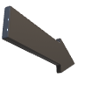



**CCS Speech Meet**

More information to come ASAP!. **Keep practicing your pieces and gettting them memorized.**

**Times announced soon!**

**DATE:** Friday, April 12th, 2019

**Where:** Lincoln Christian School

**Address**:

5801 S 84th St, Lincoln, NE 68516

Please be praying for our competors!

**Book Fair**

**When:** April 8-13th, 2019

**Where:** Pre-K thru MS Campus

