**Important Dates:**

* History Test Tues., 4/11
* Spring Program Fri., 4/21 at Salem Baptist Church
* Awards Night Wed., 5/23 at Beautiful Savior at 7p.m.

Contact Info:

**Mrs. Goodsell:**

cgoodsell@ccsnebraska.org

**Mrs. Bookless**

sarabookless@ccsnebraska.org

Fifth Grade Times Times

Penny Wars!

From April 10th-12th CCS students will be competing in Penny Wars. This is an opportunity to bless the Harder family. Each penny is a positive point, while silver coins and dollar bills will receive negative points. See the most recent PTF email for more details!

**Thank you!**

Parents and students, a special thank you to you for the flowers, cards, food, and extra love throughout teacher appreciation week. We felt overwhelmingly honored and had fun seeing the little surprises each day.

-Mrs. Bookless & Mrs. Goodsell

Great job to all of the students who competed in the Speech Meet today!

Samuel, Wilbert, Mady, Allison, Morgan, Luke, Nate, Aubrey, Elizabeth, Emily, Natalie, and Lily

Easter Break

There will be no school on Thursday, Friday, or Monday (April 13, 14, 17) as we celebrate the resurrection of our Savior!

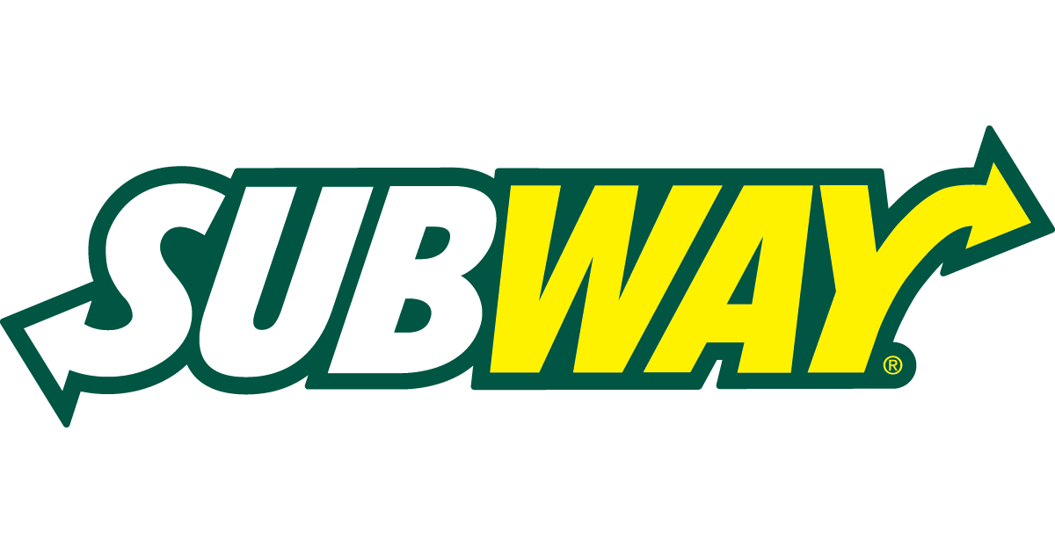

Cornerstone Family Night Out Subway @ Twin Creek Plaza April 11th, 4-10 p.m

Sports Day

Dress like your favorite athlete on Mon., April 10th!

No spelling list next week due to our short week at school.

**Saturday Night Plans?**

You are invited to theMiddle & High School Talent Show Sponsored by Cornerstone National Honor Society

• Saturday, April 8th , 6:30-8:00 pm

• Location: High School campus

• Buy tickets at the door: Adults - $3 Students - $1

• Awards for the best Middle School, High School, and overall performance • Gift cards and other prizes will be raffled off to support NHS

This is a fun night for all, you will not want to miss it!