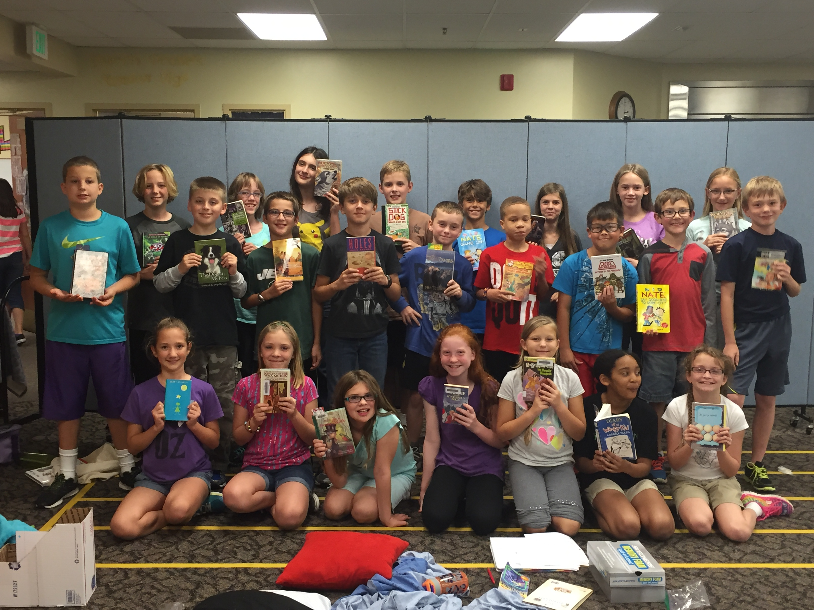

Check out more pictures from our Read-In on our website! This was a fun afternoon for our students.

**Would you help us?**

Please converse with your student about appropriate times to read in class. Although we enjoy their passion for reading, it is becoming a distraction during other subjects. Thank you for helping us with these reminders.

Memory Work:

Due: **Tuesday, October 20th**

Ephesians 2:8-9 (ESV)

For by grace you have been saved through faith. And this is not your own doing; it is the gift of God,not a result of works, so that no one may boast.

“

**Important Dates:**

* **Math Test** Wednesday 10/15
* **3D Plant/Animal Cell Model** Wednesday 10/14
* **Windy City Players** Wednesday 10/14
* **Spelling Test** Wednesday 10/21
* **Parent Teacher Conferences** Thursday 10/22
* **Christmas Program** Tuesday 12/8 at Beautiful Savior

Spelling Words

Lesson 9

1. royal
2. avoid
3. appoint
4. destroy
5. account
6. doubtful
7. moisture
8. outdoors
9. crowded
10. enjoyable
11. allowance
12. employment
13. conifer
14. canopy
15. deciduous
16. timberline
17. evergreen
18. temperate
19. lumberjack
20. memorial
21. memory
22. revise
23. revision

Challenge Words

1. discrimination
2. paraphrase

**Mrs. Goodsell:**

cgoodsell@ccsnebraska.org

**Mrs. Bookless**

sarabookless@ccsnerbaska.org

Contact Info:

5th Grade Times